**FINAL INCREMENT**

**FORECASTING HEART PROBLEMS**

**BY IMPLEMENTING MACHINE LEARNING ALGORITHMS.**

**PROJECT BATCH**

7007429050 **-** Mareedu Sai Sritha

700742428 - Rishitha Reddy

700734096 - Nandini Ramshetty

700741157 - Sai Sumanth

**UPDATED WORK :**

Till now, we have done checking the accuracy for heart disease prediction dataset with each machine learning algorithm. Now, we have developed a GUI Interface to our project with the tkinter library. This GUI block helps to predict the heart disease quick and accurately. After running the GUI block we get a table with all the attributes of the dataset after we enter the desired values and click on predict submission button then it checks with the range limit and gives the output as **No heart disease** or **possibility of heart disease.**

tk:

The Tk application object made by starting up Tk. This gives admittance to the Tcl mediator. Every gadget that is joined a similar occasion of Tk has similar incentive for its tk trait.

master:

The gadget object that contains this gadget. For Tk, the expert is None since it is the principal window. The terms expert and parent are comparable and once in a while utilized conversely as contention names; in any case, calling winfo_parent() returns a line of the gadget name though ace returns the item. parent/youngster mirrors the tree-like relationship while ace/slave mirrors the compartment structure.

**CODE WITH RESULTS :**

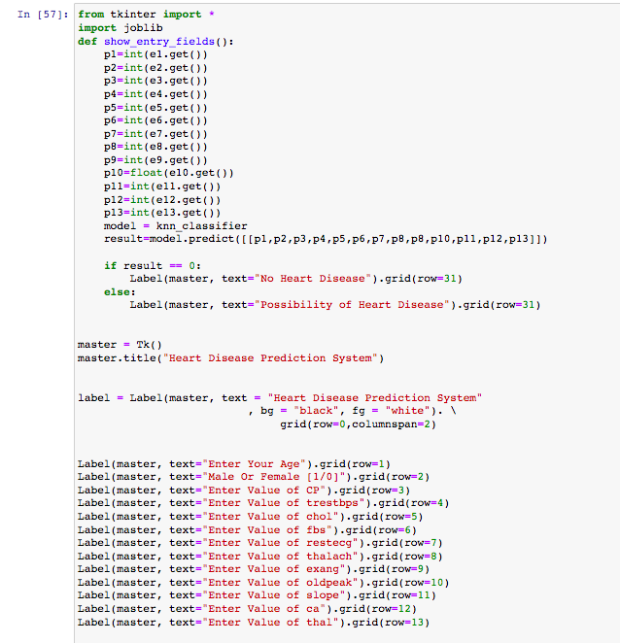

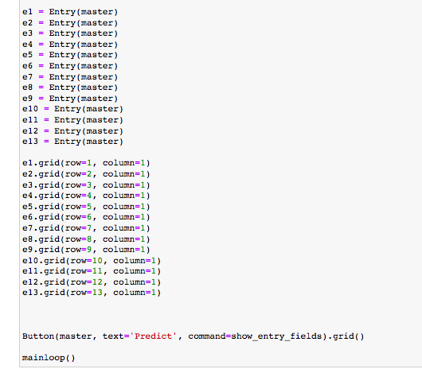

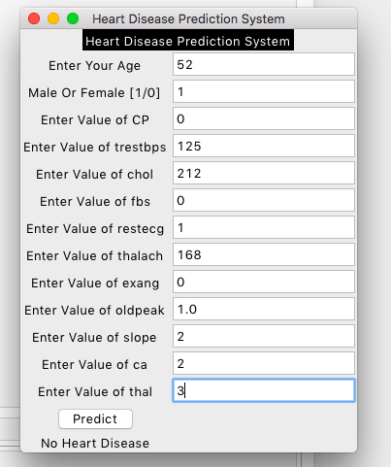

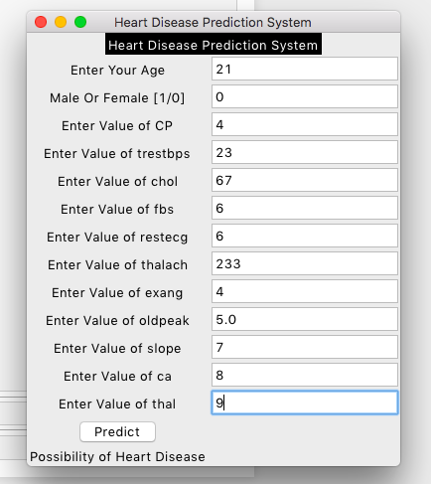

**CONCLUSION:**

Our project final motive is to predict heart disease in early stage with cost friendly. We can test this just by sitting at home we have done all the operations on the dataset to obtain better accuracy and have developed GUI to predict the chances.